Discussion of Results

Delaying DAC deployment from 2035 to 2040, as shown in the figure below and based on the Navius data, is associated with an increased dependence on conventional emission cuts to achieve net zero, as well as a reduction in cumulative DAC sequestration through 2050 (see SI Appendix 3 – DAC Deployment Ranges.png). The light transport sector is most affected by this delay, with late CDR deployment associated with 15 to 41% less emissions between 2035 and 2050 – a drop that can be attributed to more ambitious mitigation measures in a sector that is more amenable to decarbonization, driven by existing advances in alternative technologies. Medium and heavy transport, oil and gas, and industry also exhibit larger emission reductions in the case of a 2040 rollout, with the sectors achieving additional cuts of 15, 16, and 8%, respectively, in 2050. The change in emissions is almost negligible for agriculture and waste, as well as residential and commercial buildings. These HtA sectors have stubborn residual emissions that are unlikely to be avoided regardless of the timing of a CDR rollout, including diffuse, non-CO₂ emissions and the slow turnover of building stock, respectively. As for the utilities sector, its emissions rise if the DAC rollout is delayed; this is likely due to the fundamental role electricity plays in economy-wide decarbonization, and the associated emission cuts in other sectors mandated by the delayed implementation of CDR. Absolute sectoral emissions and differentials are presented in several formats in SI Appendix 3.
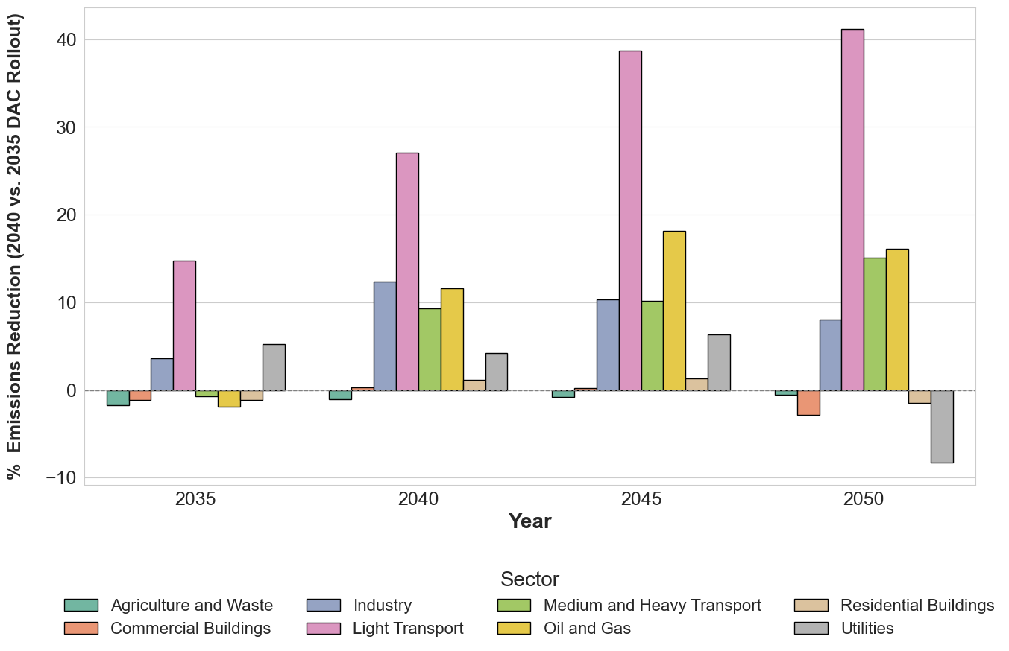
Percent Reductions in Sectoral Emissions Associated with Delayed DAC Rollout (Navius). This bar chart presents the percentage changes in sectoral emission levels associated with delaying a DAC rollout from 2035 to 2040 in five-year intervals through 2050. Positive bars represent emission reductions, while negative bars represent emission increases. Sectors whose emissions are noticeably smaller in the case of a 2040 rollout compared to a 2035 rollout undergo increased mitigation to offset the delay in CDR deployment.

